**ServiceNow System Administrator**

**Streamlining Ticket Assignment for Efficient Support Operations**

**Category: ServiceNow Application Developer**

**Project Description:**

The objective of this initiative is to implement an automated system for ticket routing at ABC Corporation, aimed at improving operational efficiency by accurately assigning support tickets to the appropriate teams. This solution aims to reduce delays in issue resolution, enhance customer satisfaction, and optimize resource utilization within the support department.

**1. Users**

Create Users

Open service now

Click on All >> search for users

Select Users under system security

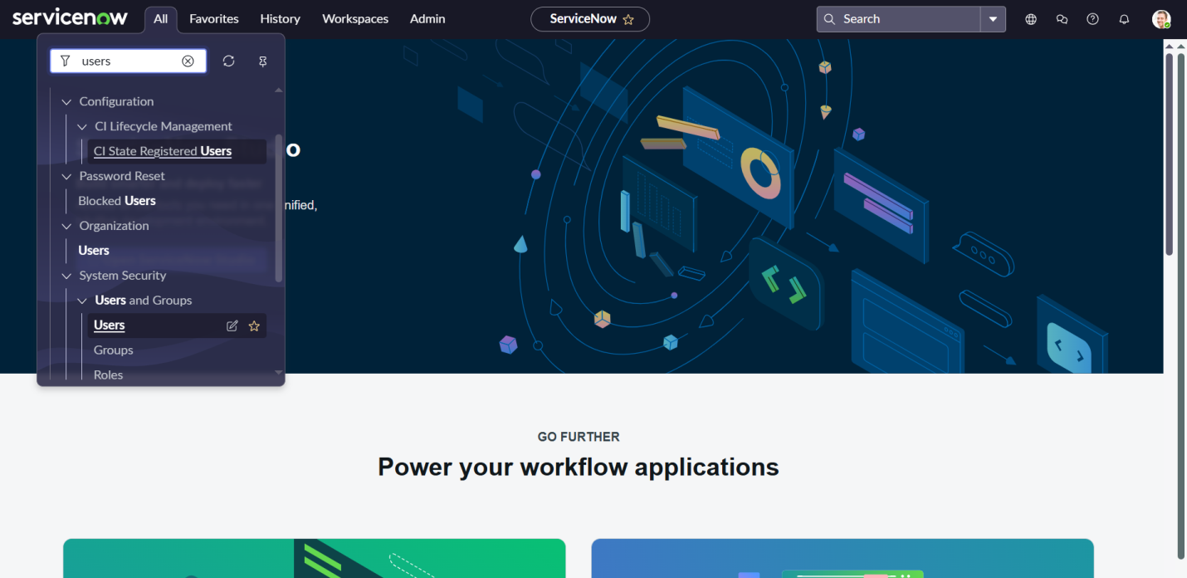

Click on new

Fill the following details to create a new user

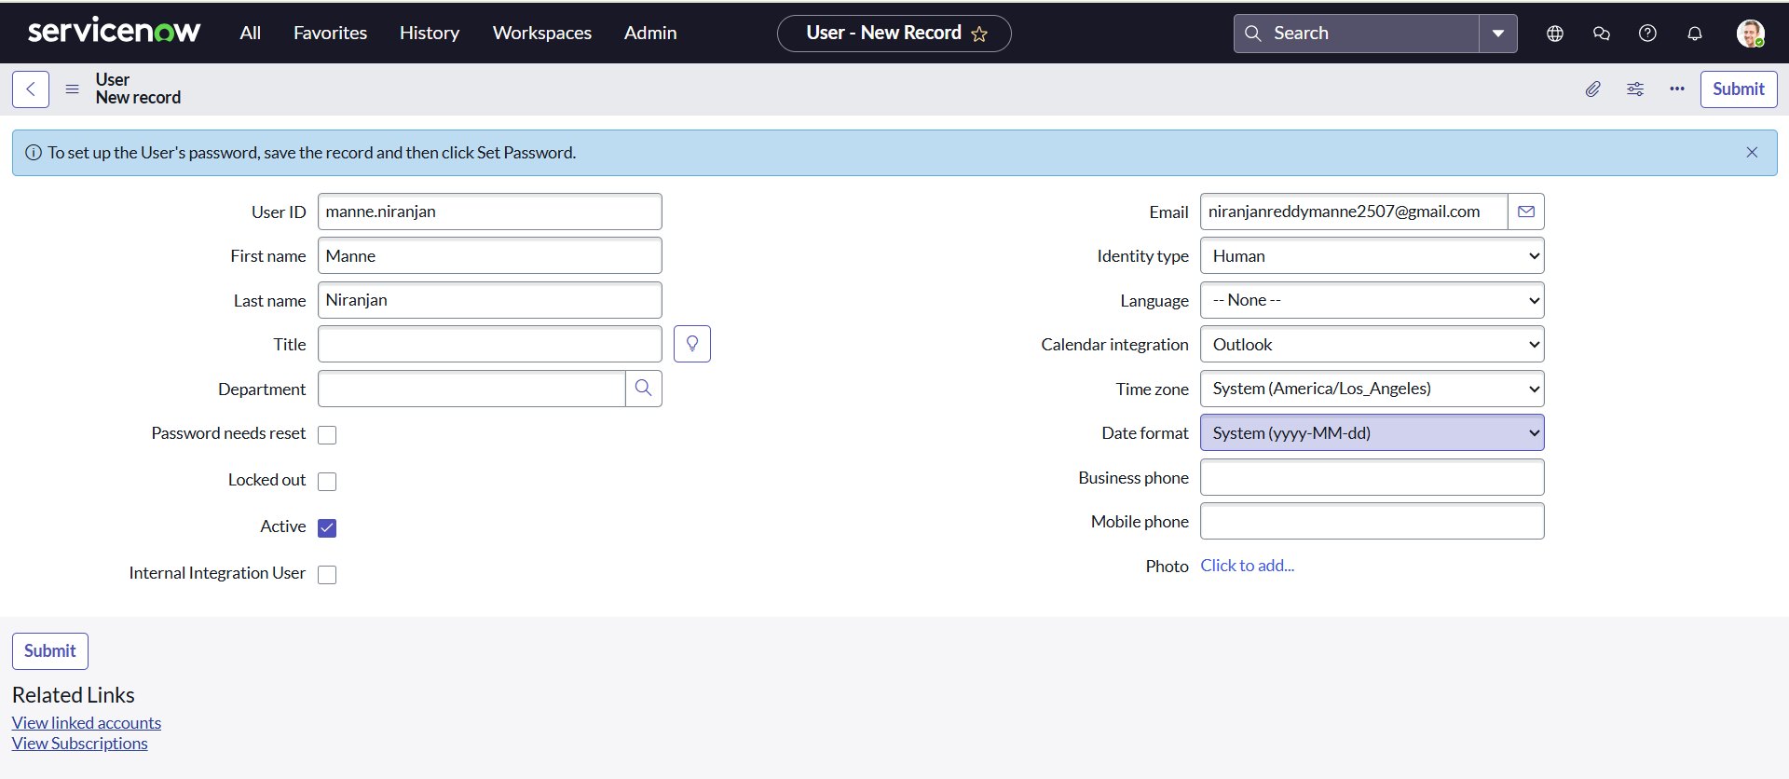

Click on submit

Create one more user :

Create another user with the following details

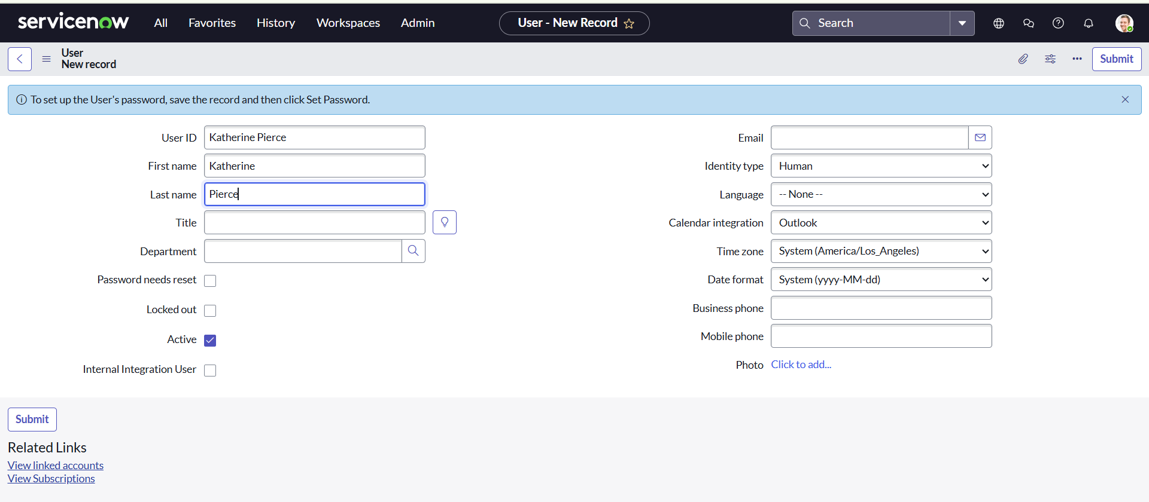

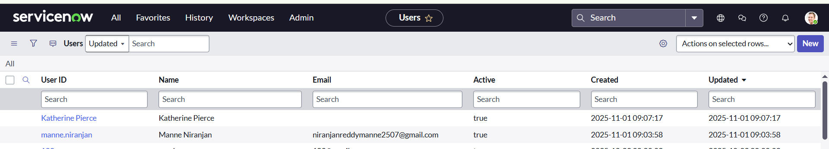

**2. Groups**

Open service now.

Click on All >> search for groups

Select groups under system security

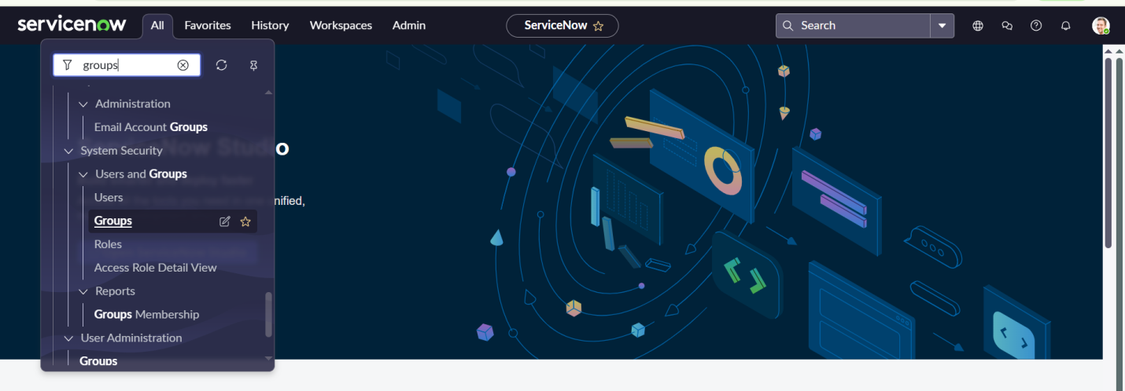

Click on new

Fill the following details to create a new group

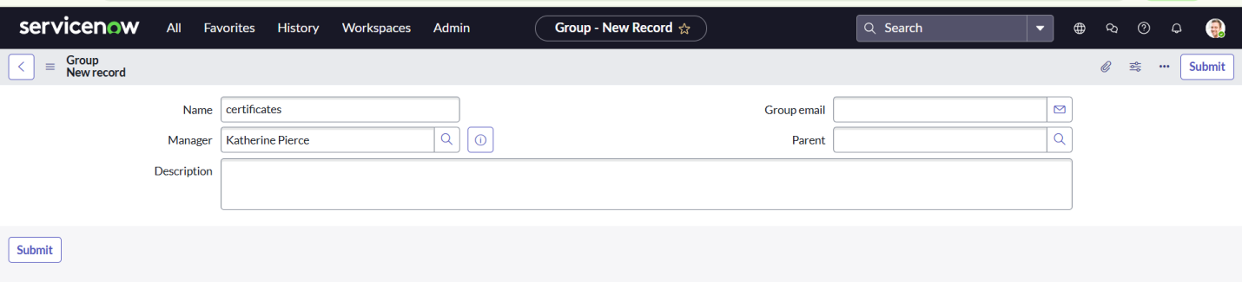

Create one more group:

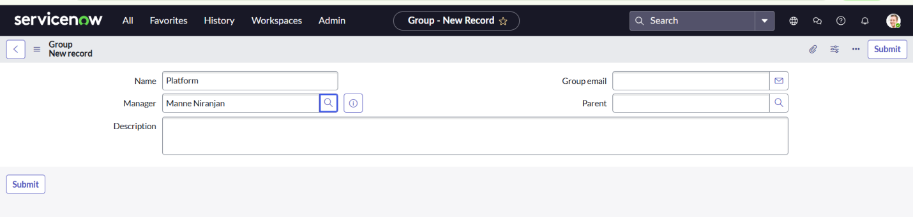

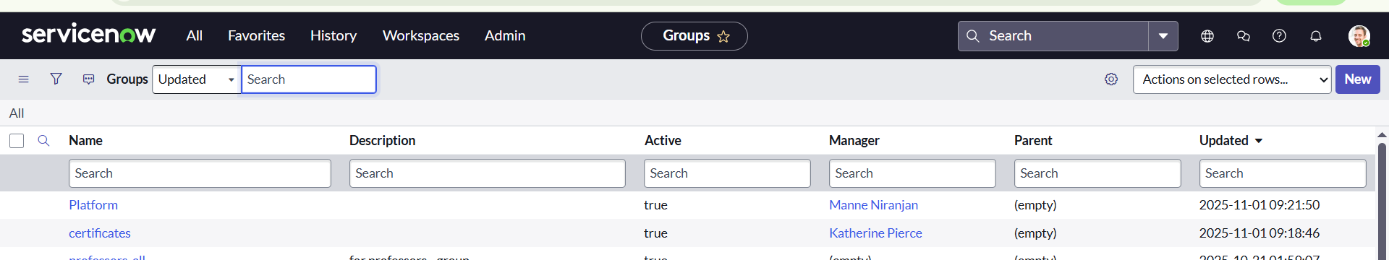

**3. Roles**

Open service now.

Click on All >> search for roles

Select roles under system security

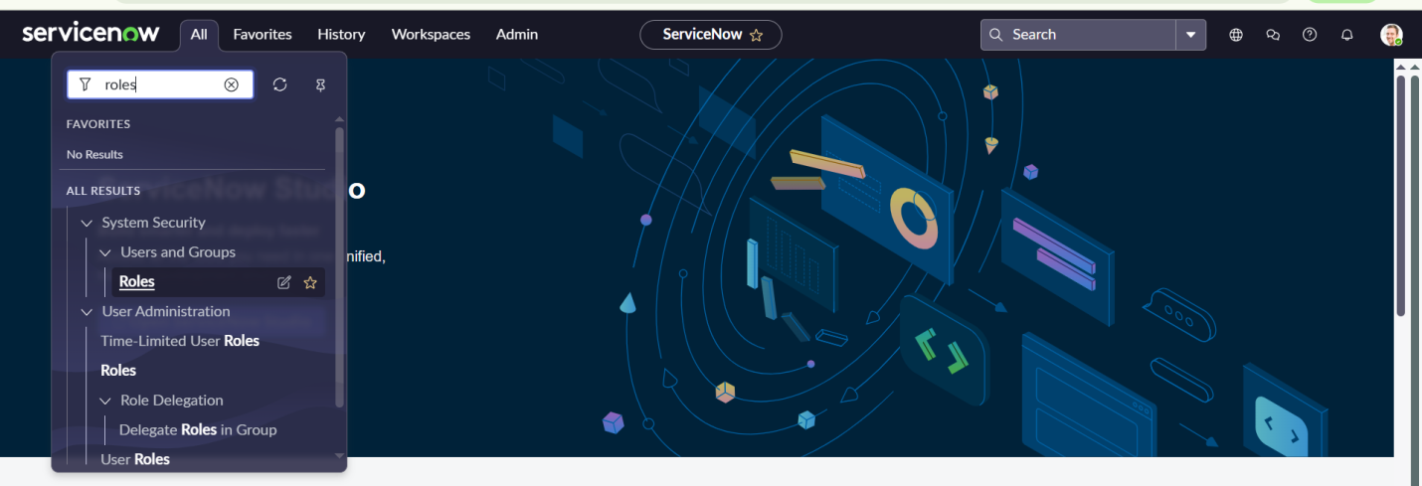

Click on new

Fill the following details to create a new role

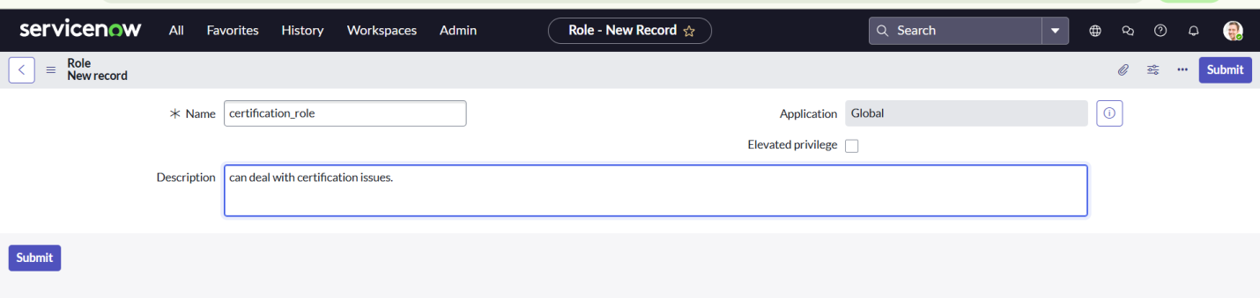

Create one more role:

Create another role with the following details

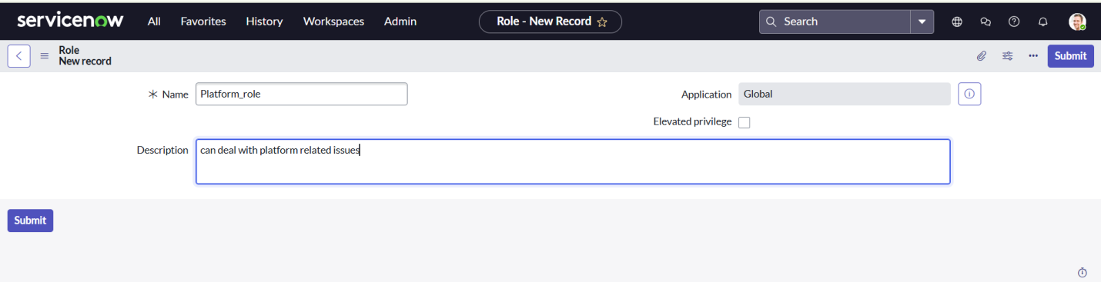

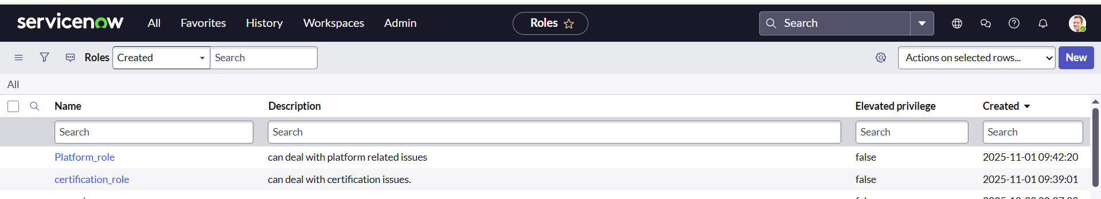

**4. Table**

Open service now.

Click on All >> search for tables

Select tables under system definition

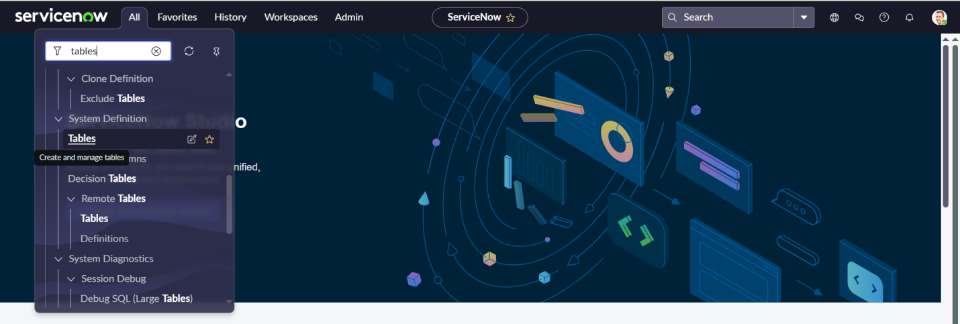

Click on new

Fill the following details to create a new table

Label : Operations related

Check the boxes Create module & Create mobile module

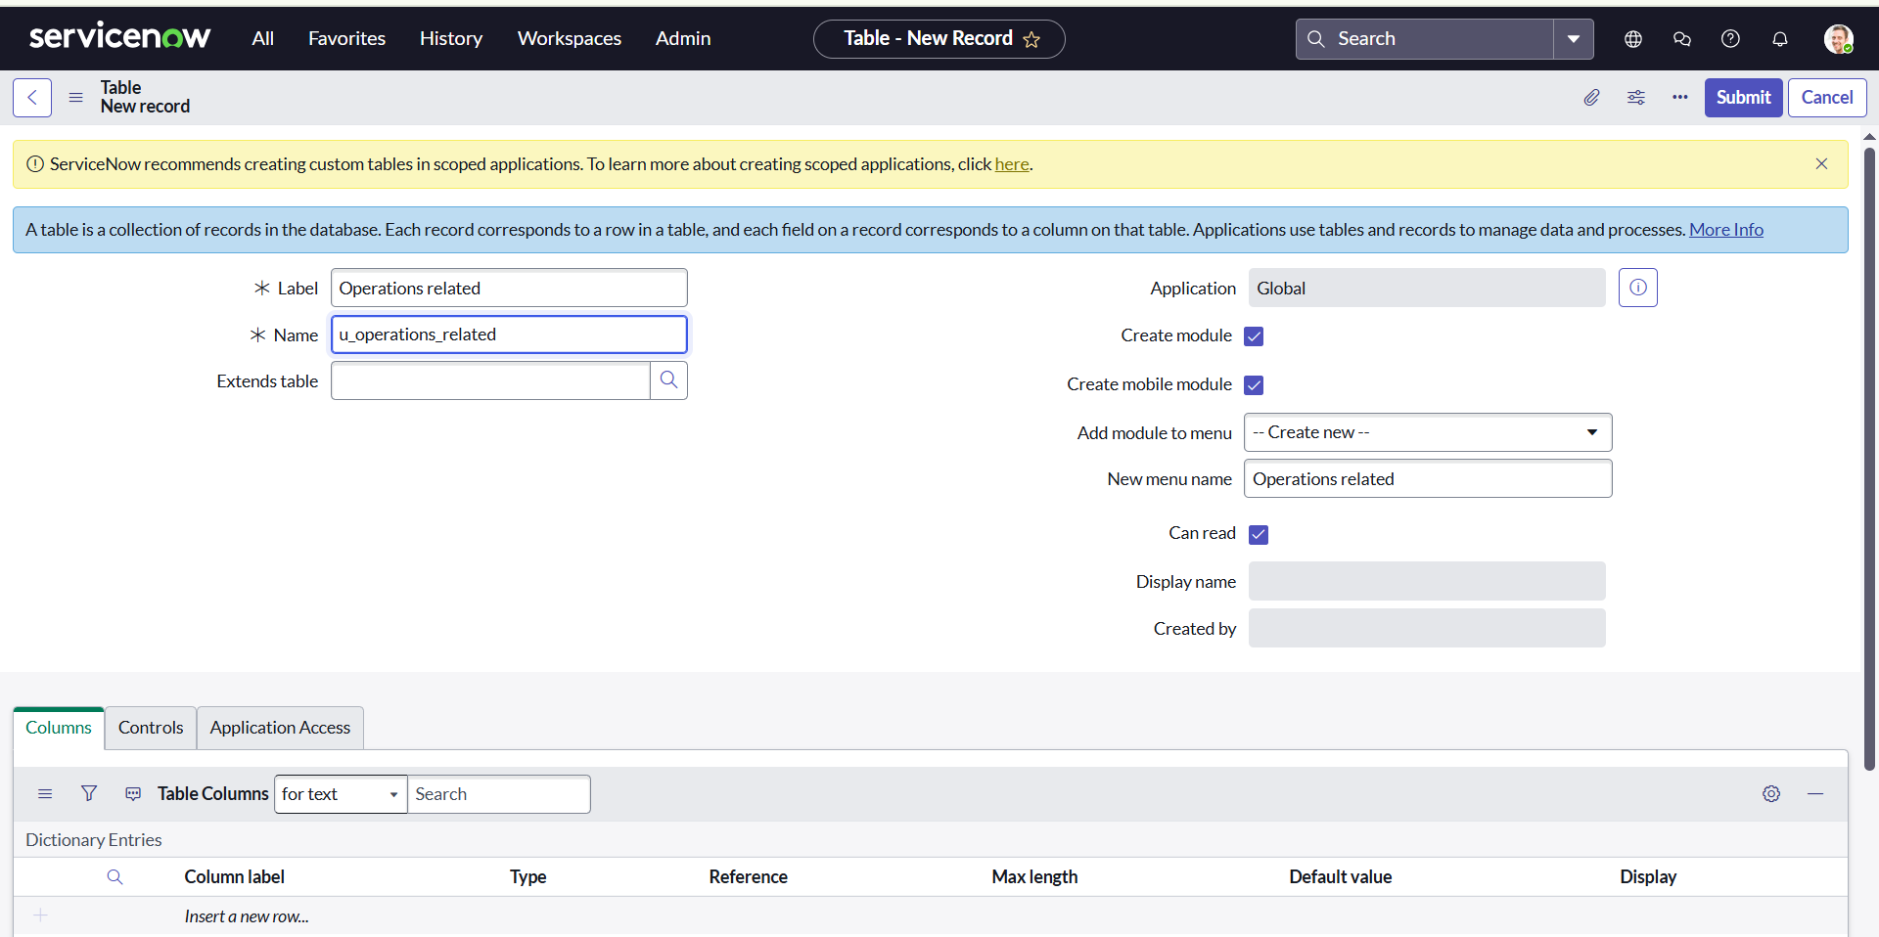

Under table columns give the columns

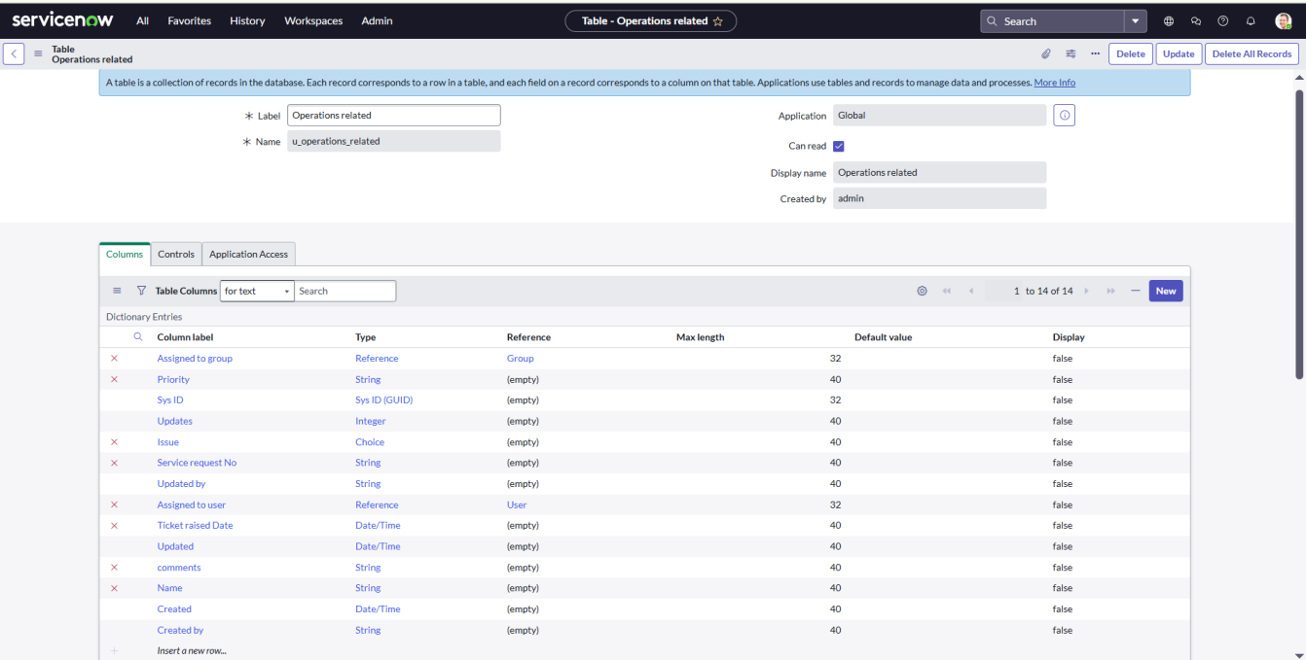

Create choices for the issue filed by using form design

Choices are:

unable to login to platform

404 error

regarding certificates

regarding user expired

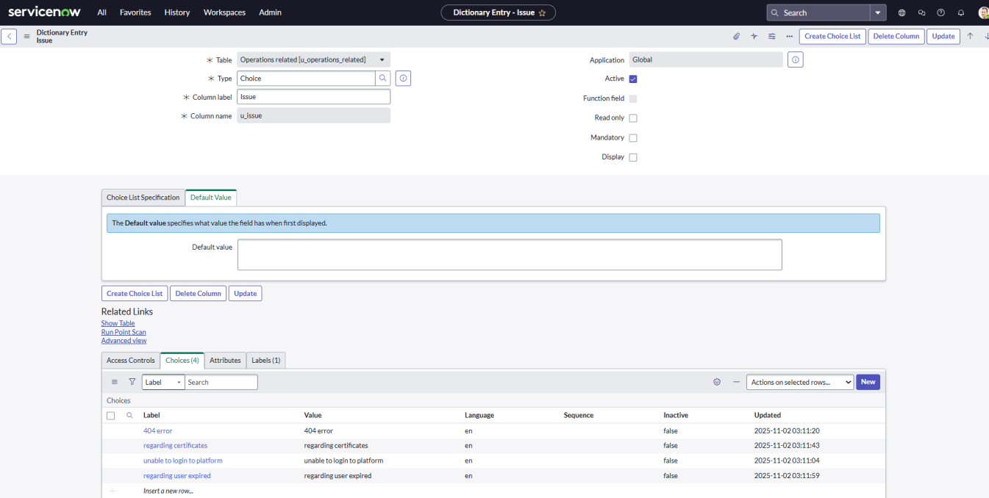

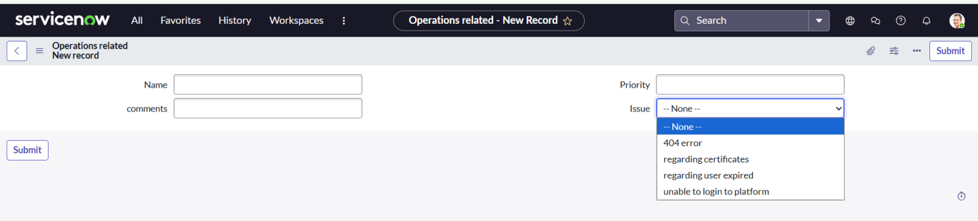

**5. Assign roles & users to groups**

**a. Assign roles & users to certificate group**

Open service now.

Click on All >> search for tables

Select tables under system definition

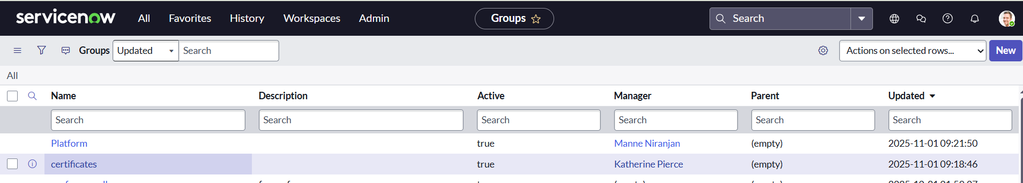

Select the certificates group

Under group members

Click on edit

Select Katherine Pierce and save

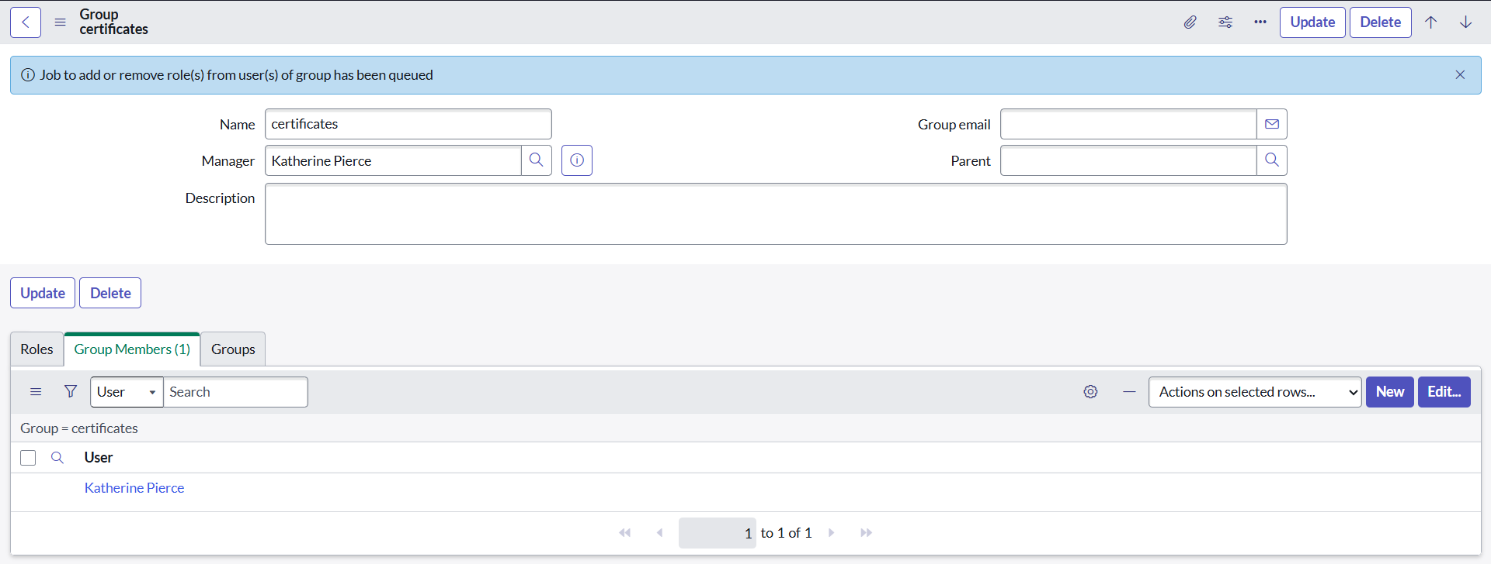

Click on roles

Select Certification_role and save

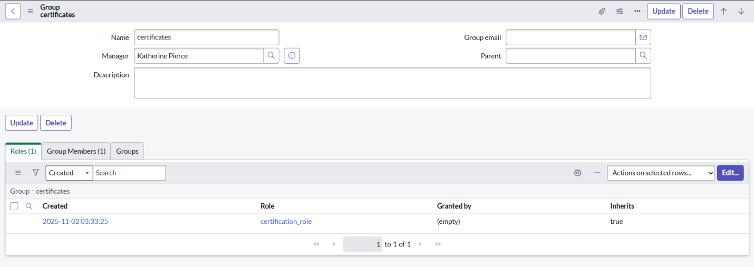

**b. Assign roles & users to platform group**

Open service now.

Click on All >> search for tables

Select tables under system definition

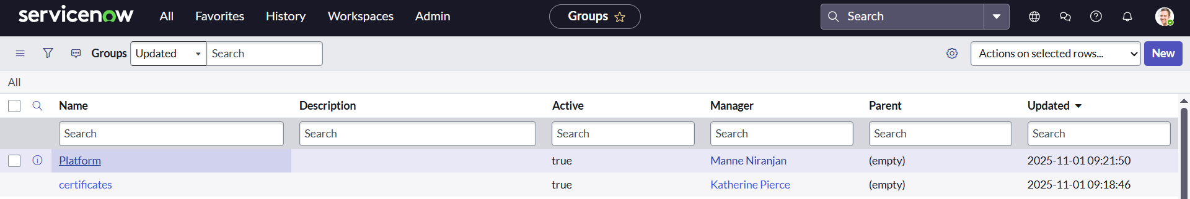

Select the platform group

Under group members

Click on edit

Select Manne Niranjan and save

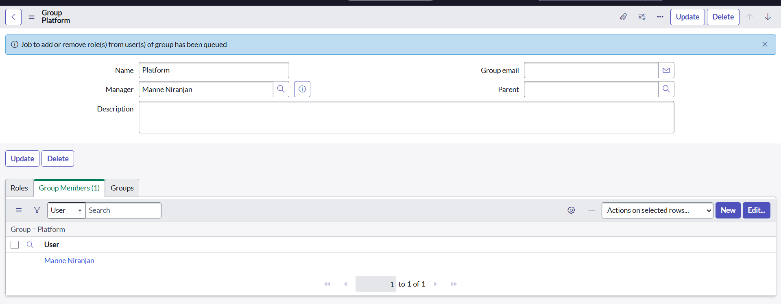

Click on roles

Select Platform_role and save

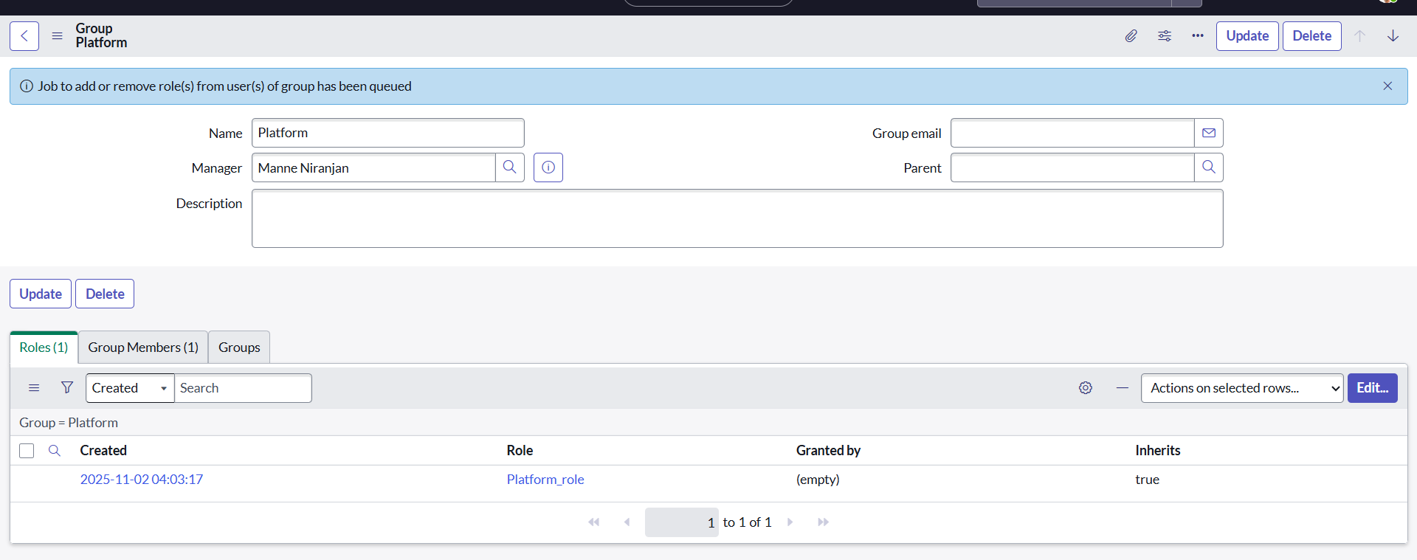

**6. Assign role to table**

Open service now.

Click on All >> search for tables

Select operations related table

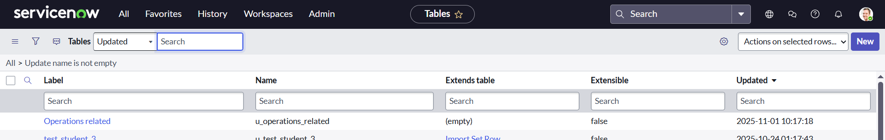

Click on the Application Access

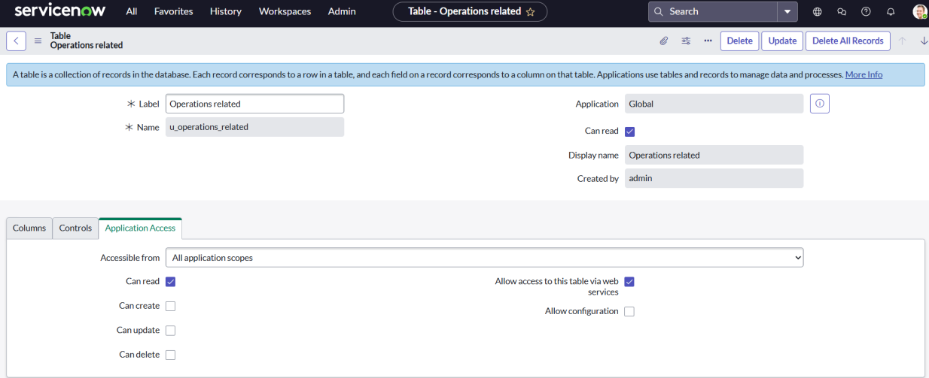

Click on u_operations_related read operation

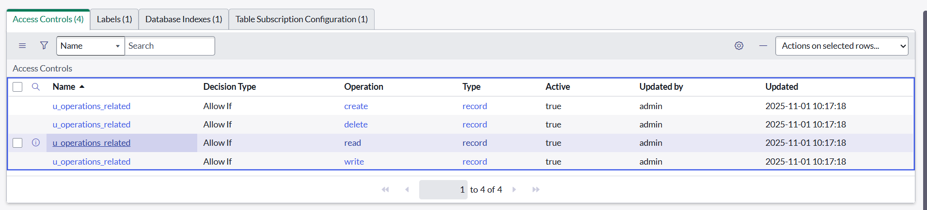

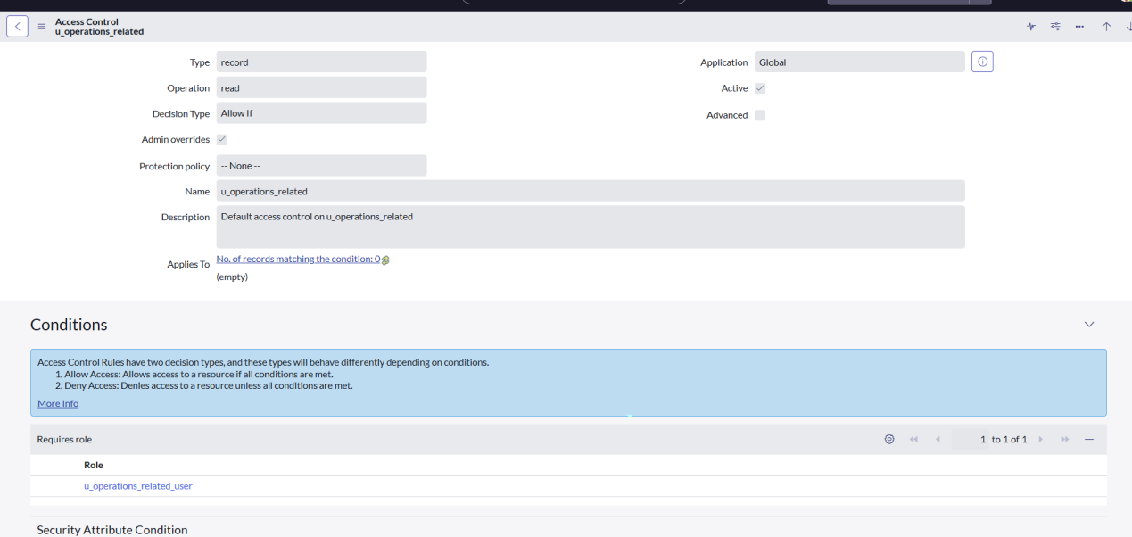  
Click on the profile on top right side

Click on elevate role 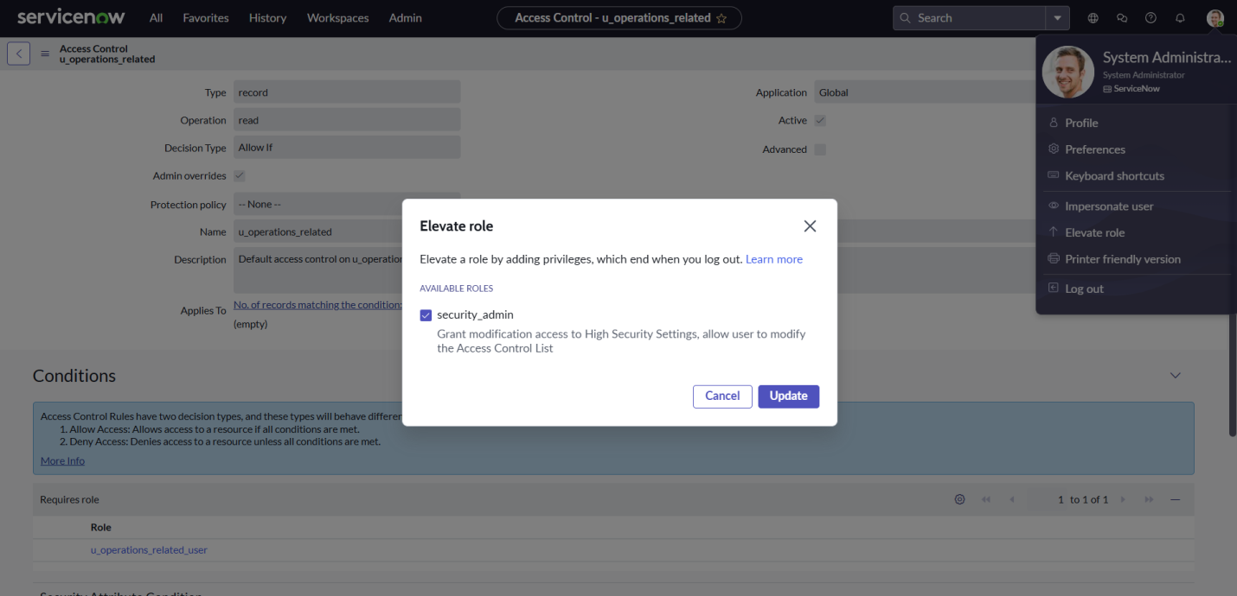

Click on security admin and click on update

Under Requires role

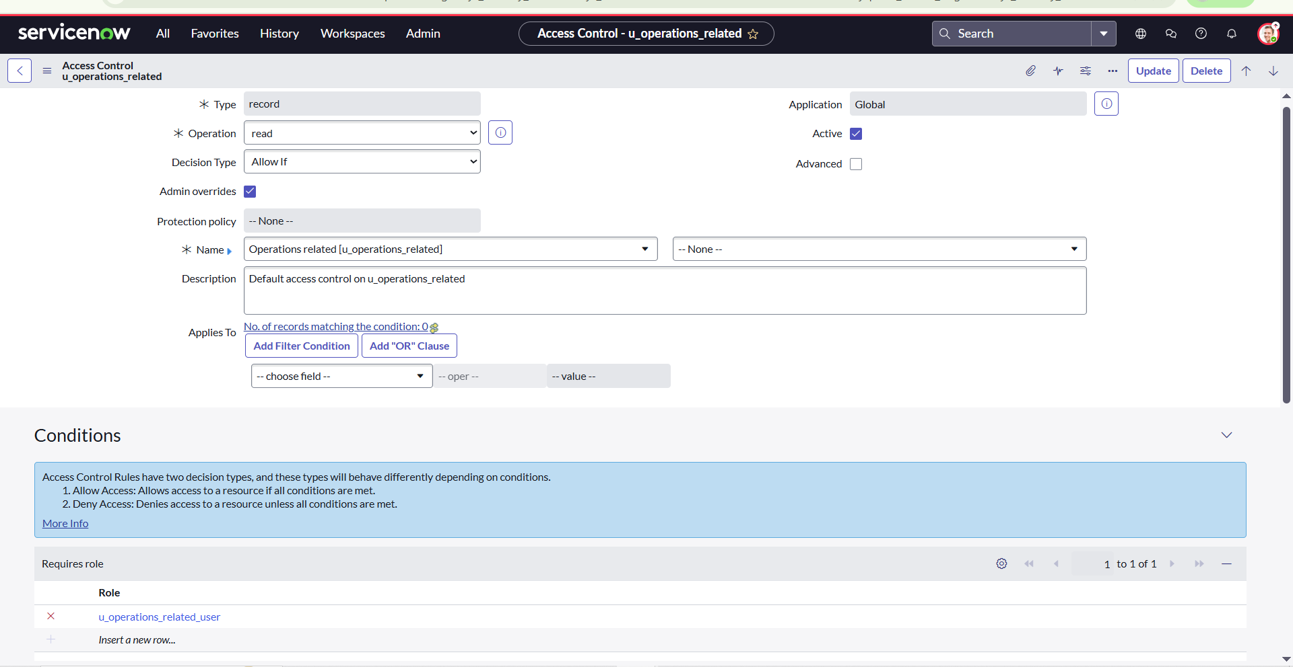

Double click on insert a new row

Give platform role

And add certificate role

Click on update

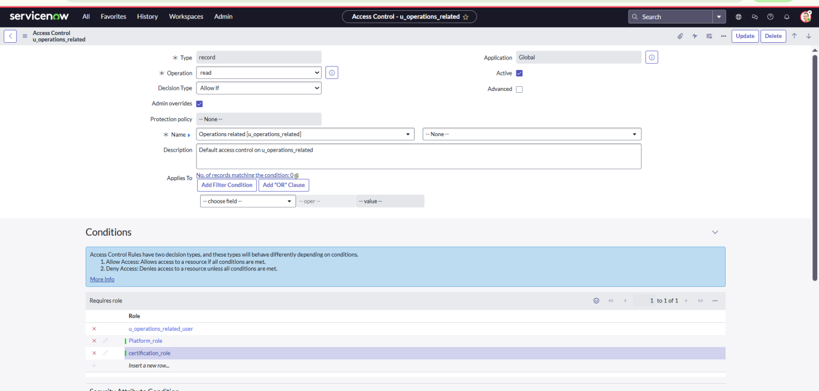

Click on u_operations_related write operation

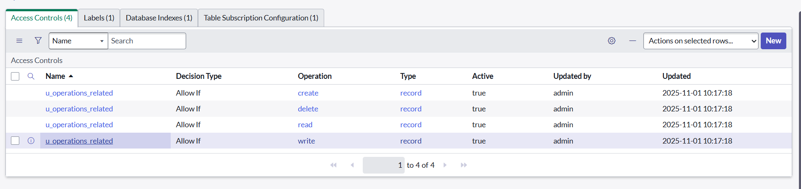

Under Requires role

Double click on insert a new row

Give platform role

And add certificate role

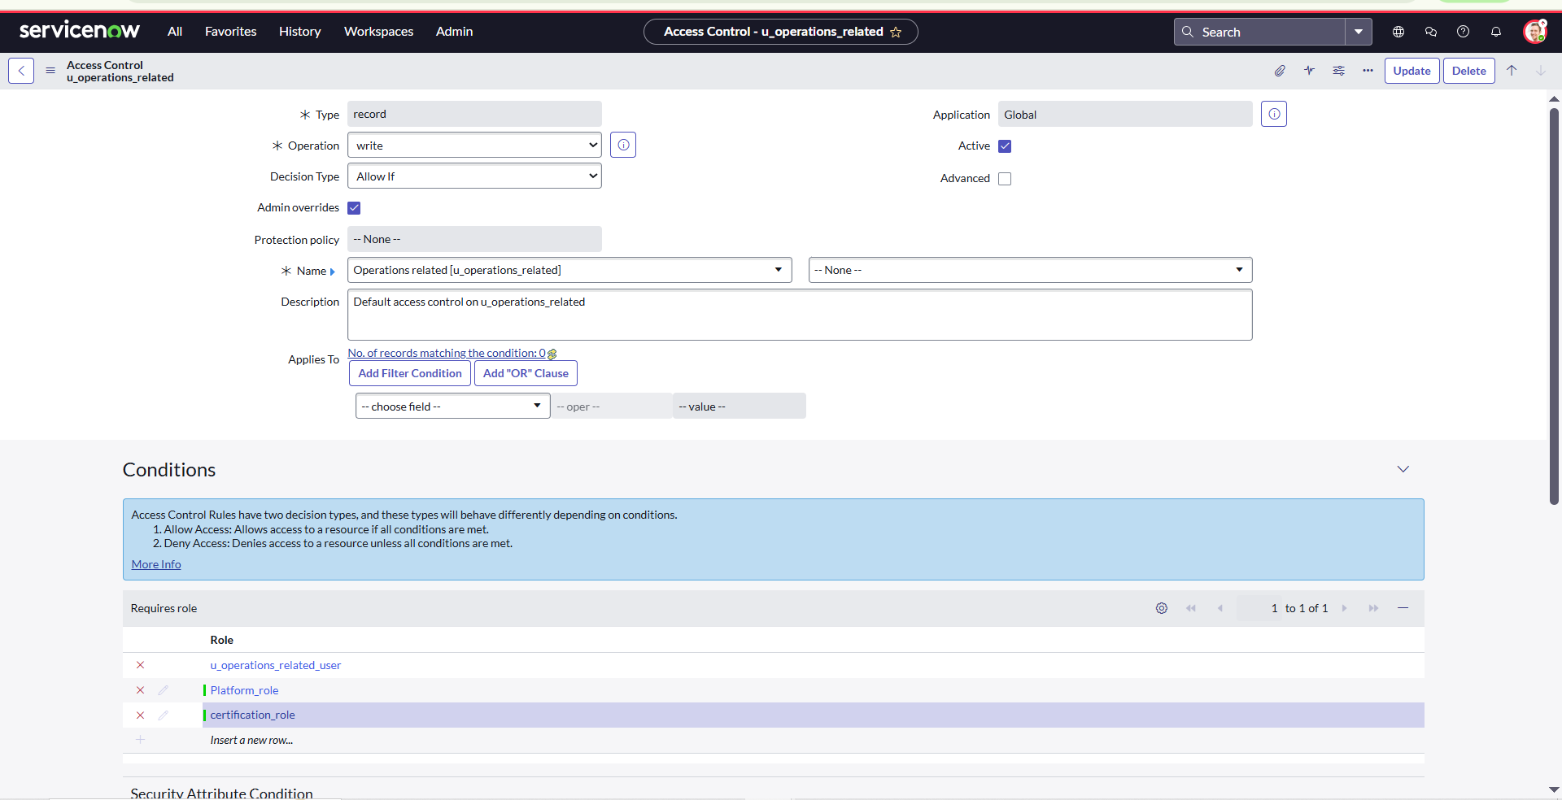

**7. Create ACL**

Open service now.

Click on All >> search for ACL

Select Access Control(ACL) under system security

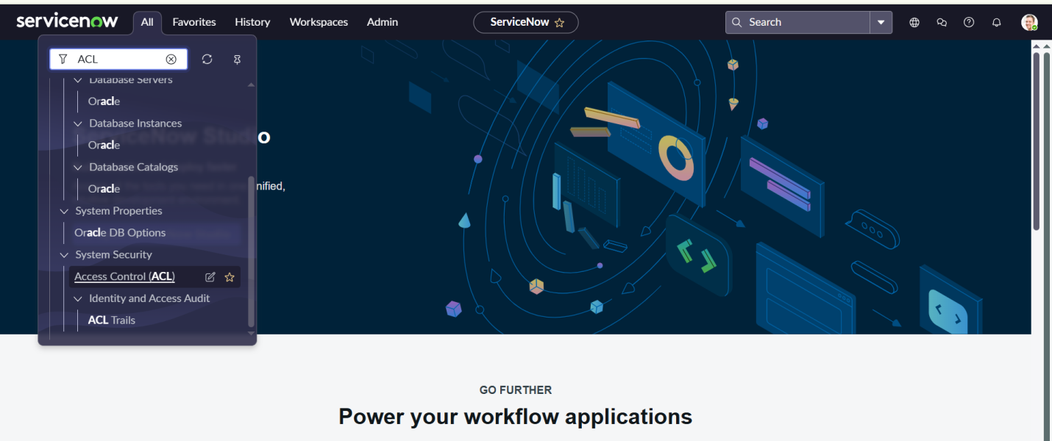

Without Elevate role you can’t see the new button



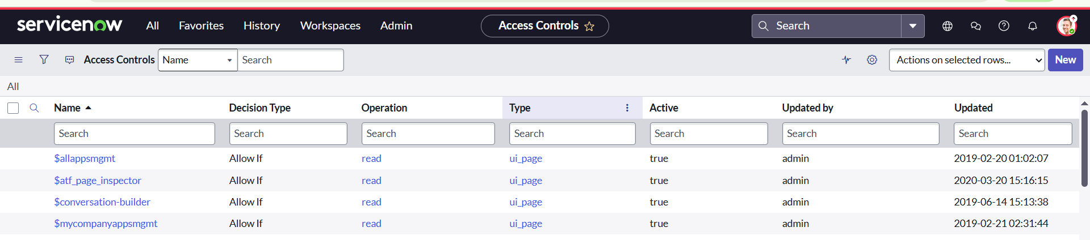

Click on **new**

Fill the following details to create a new ACL

Scroll down under requires role

Double click on insert a new row

Give admin role

Click on submit

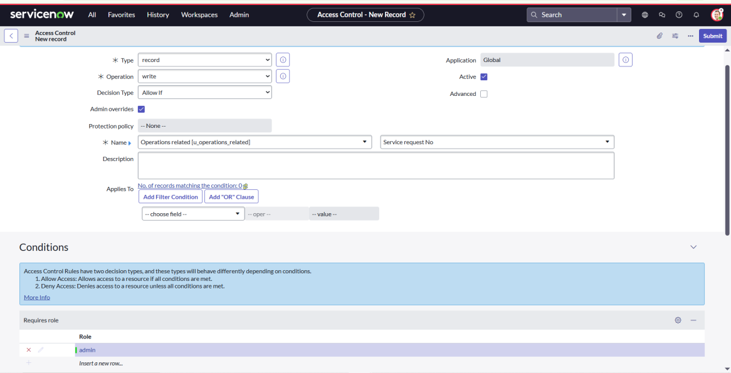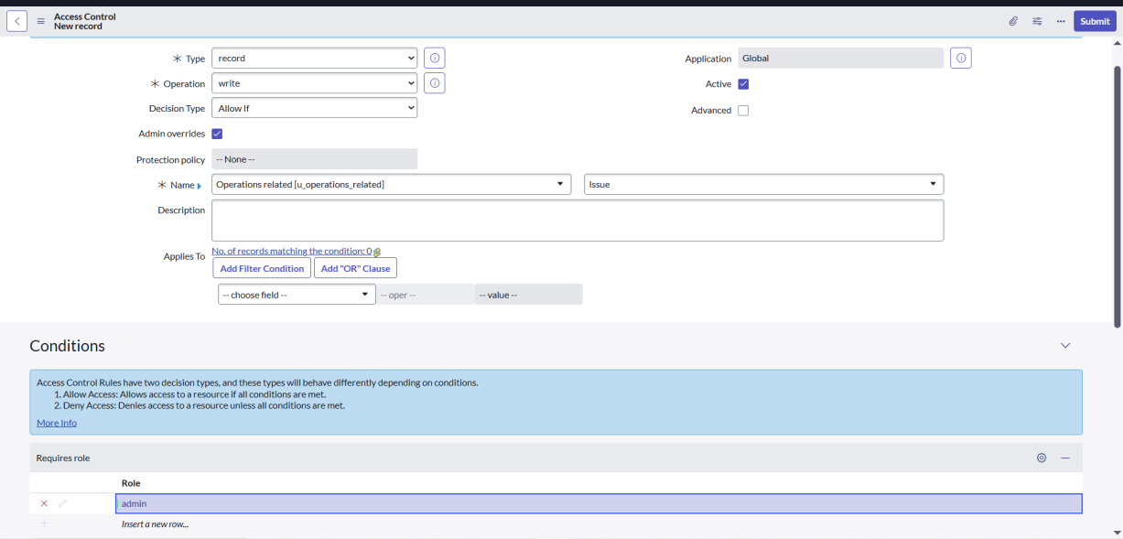

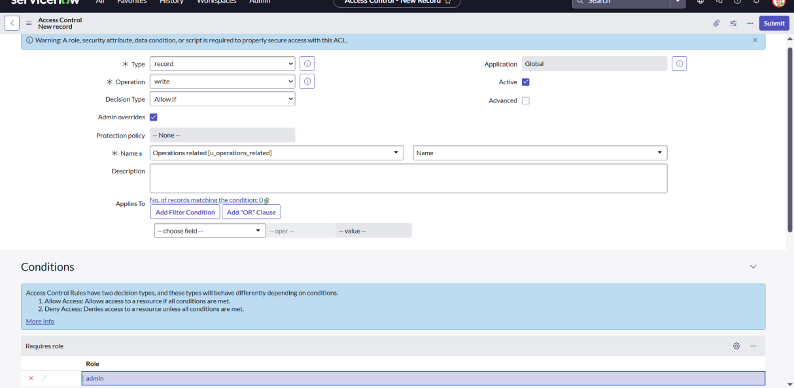

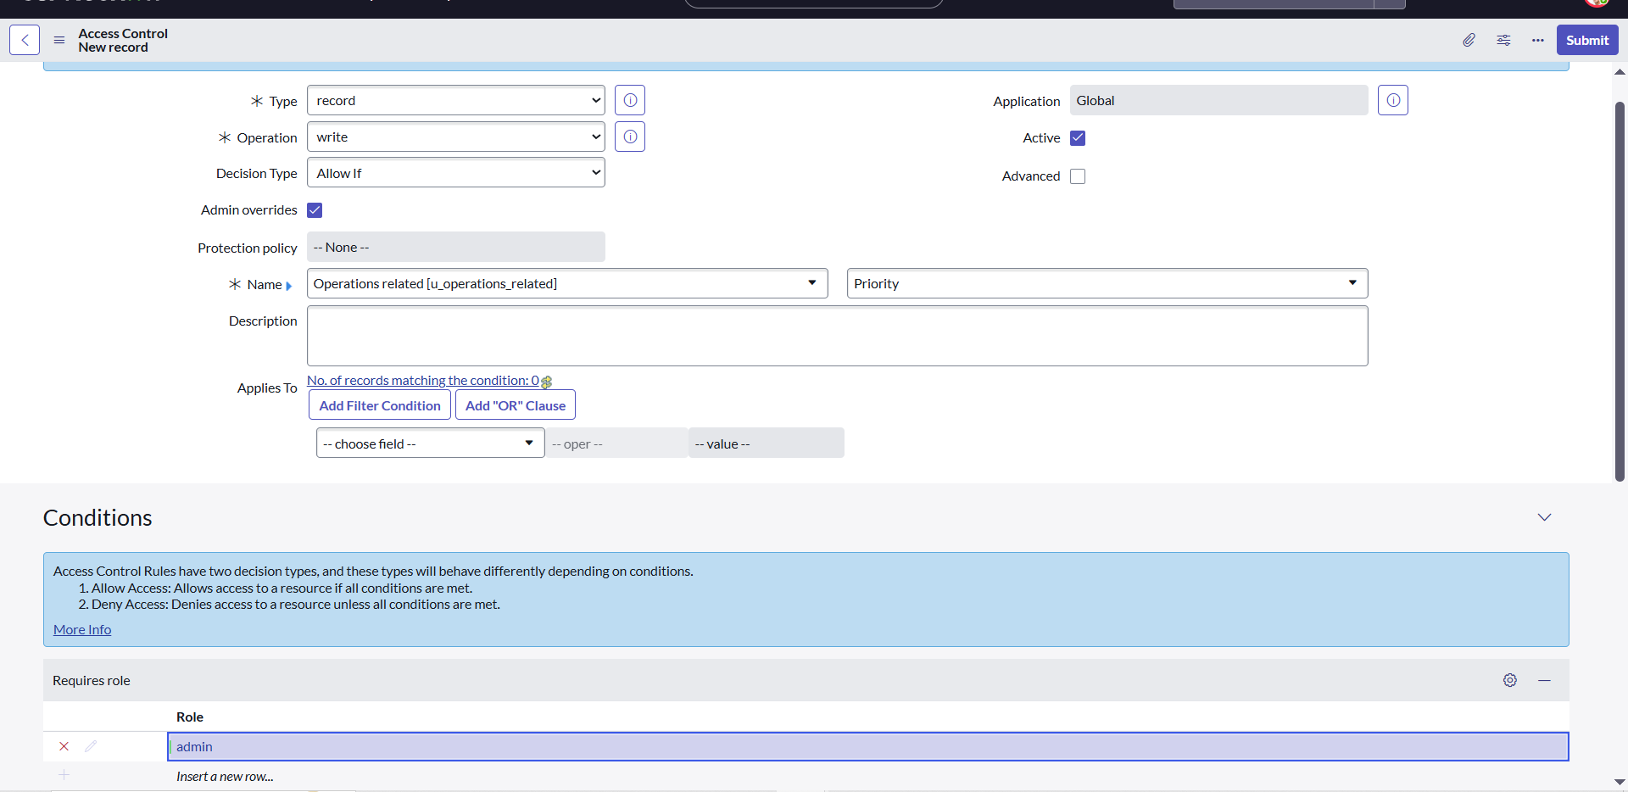

Similarly create 4 acl for the following fields

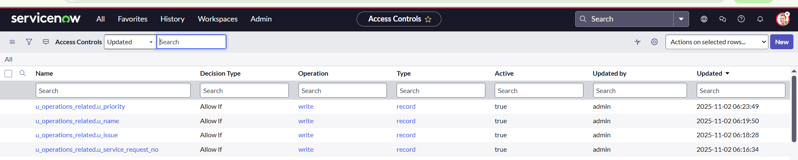

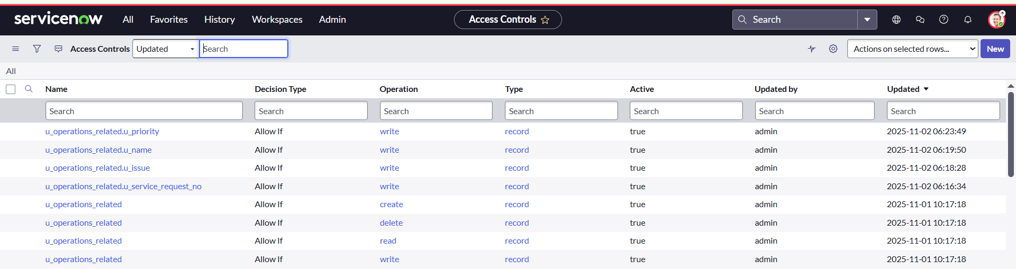

**8. Flow**

**a. Create a Flow to Assign operations ticket to group**

Open service now.

Click on All >> search for Flow Designer

Click on Flow Designer under Process Automation.

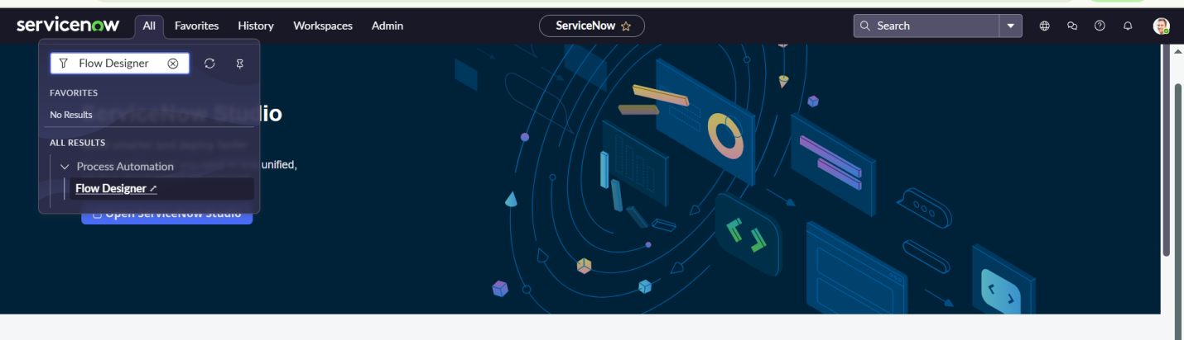

After opening Flow Designer Click on new and select Flow.

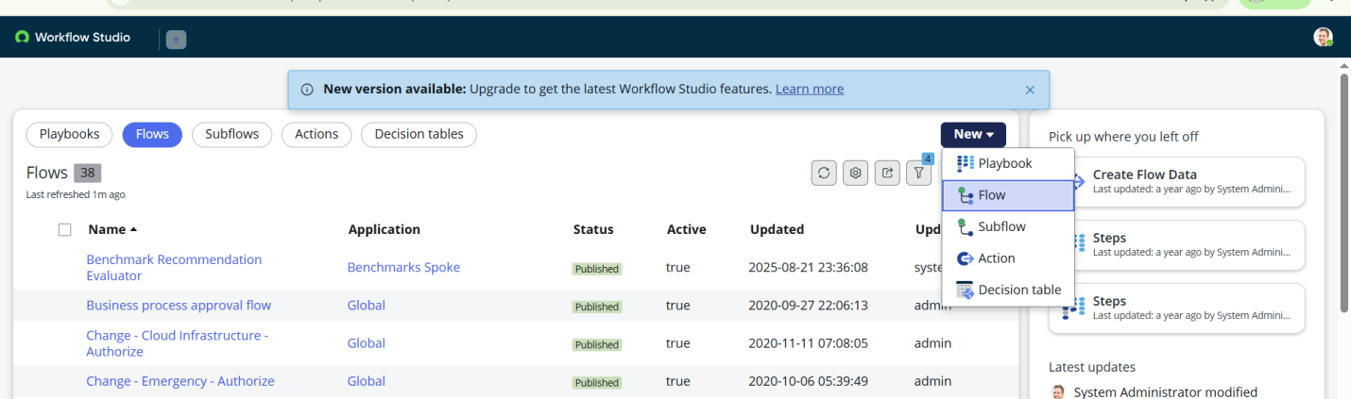

Under Flow properties Give Flow Name as “ Regarding Certificate”.

Application should be Global.

Select Run user as “ System user ” from that choice.

Click on Submit.

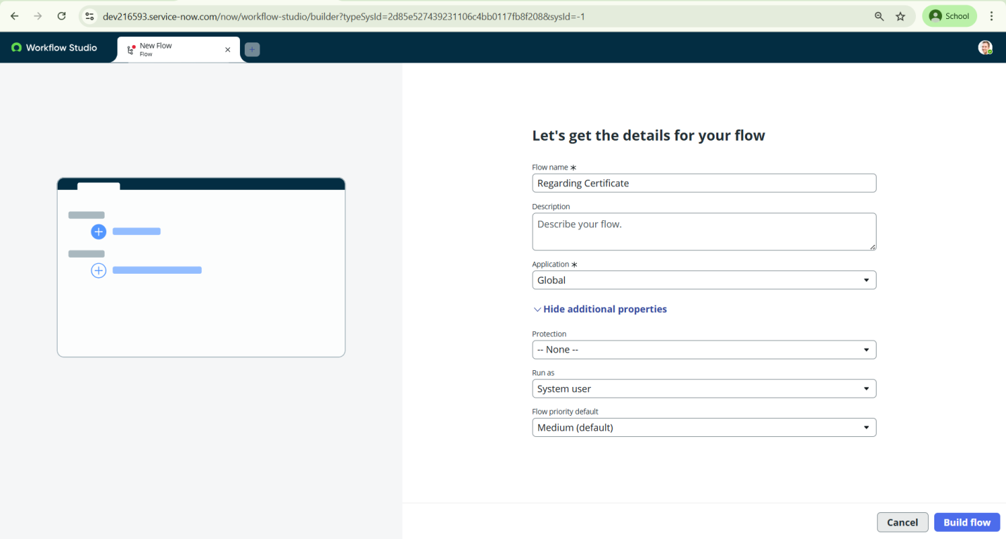

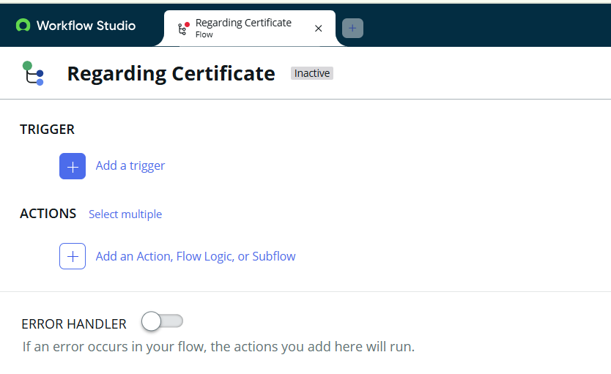

Click on Add a trigger

Select the trigger in that Search for “create or update a record” and select that.

Give the table name as “ Operations related ”.

Give the Condition as

Field : issue

Operator : is

Value : Regrading Certificates

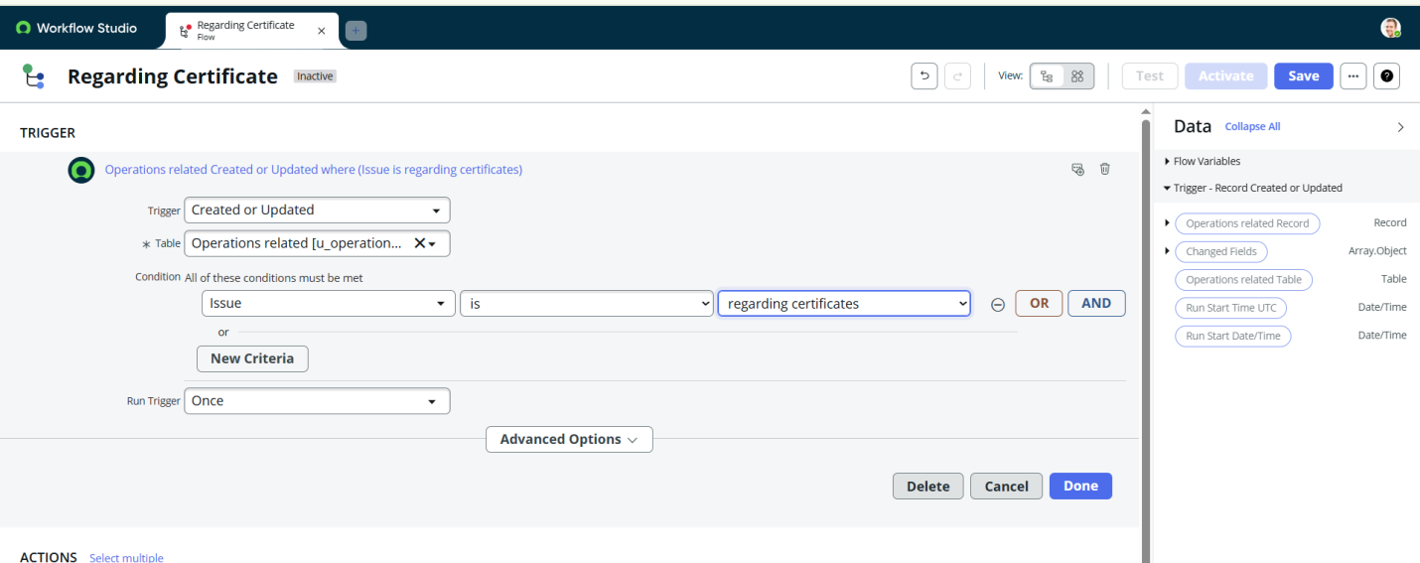

After that click on Done.

Now under Actions.

Click on Add an action.

Select action in that search for “ Update Record ”.

In Record field drag the fields from the data navigation from left side

Table will be auto assigned after that

Give the field as “ Assigned to group ”

Give value as “ Certificates ”

Click on Done.

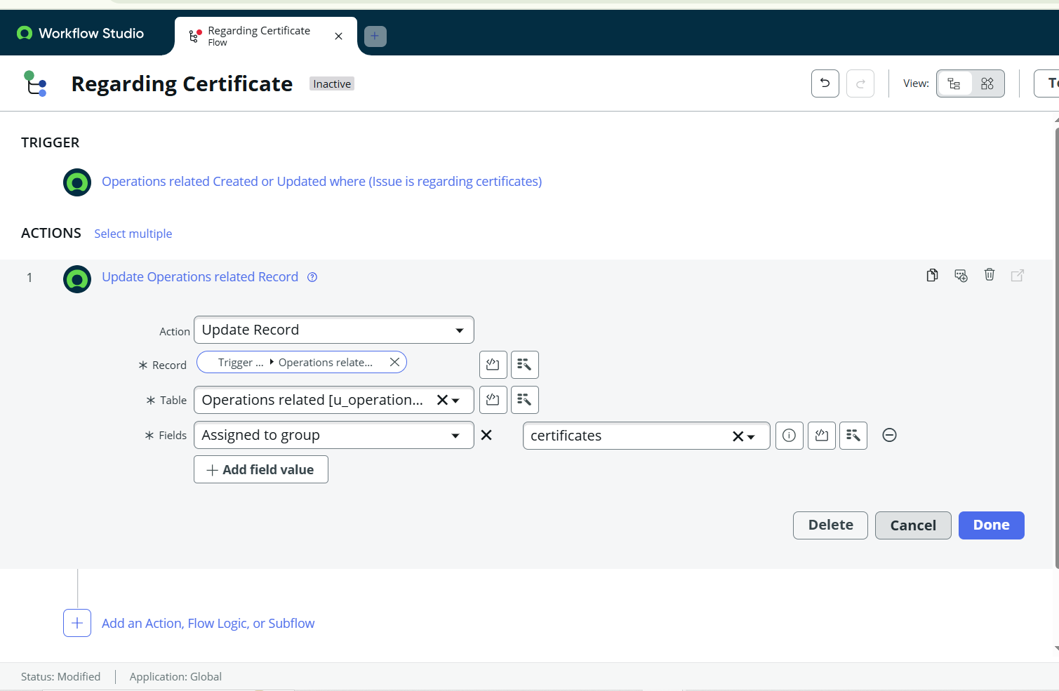

Click on Save to save the Flow.

Click on Activate.

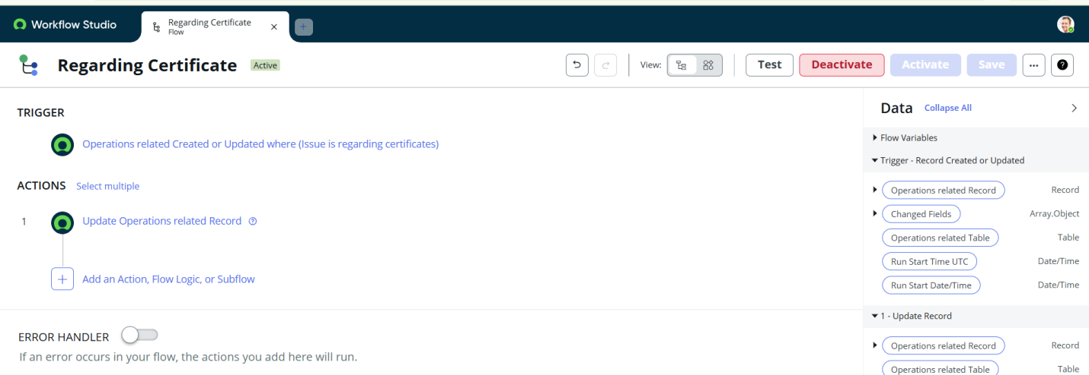

**b. Create a Flow to Assign operations ticket to Platform group**

Open service now.

Click on All >> search for Flow Designer

Click on Flow Designer under Process Automation.

After opening Flow Designer Click on new and select Flow.

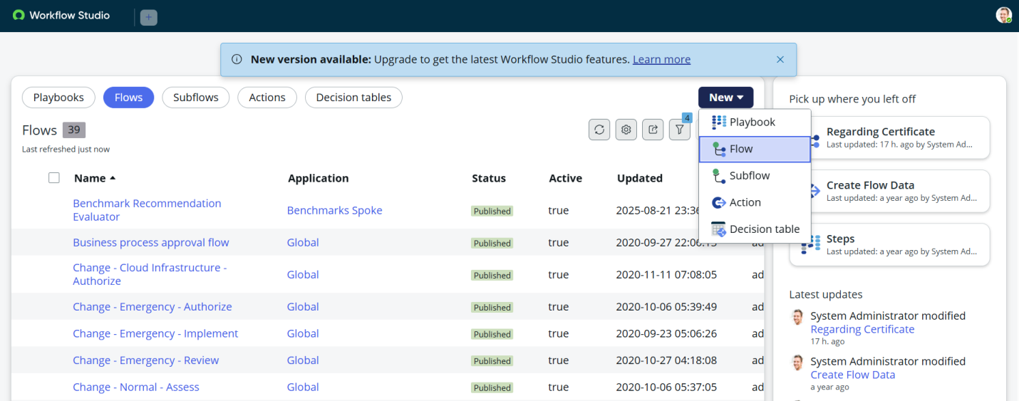

Under Flow properties Give Flow Name as “ Regarding Platform ”.

Application should be Global.

Select Run user as “ System user ” from that choice.

Click on Submit.

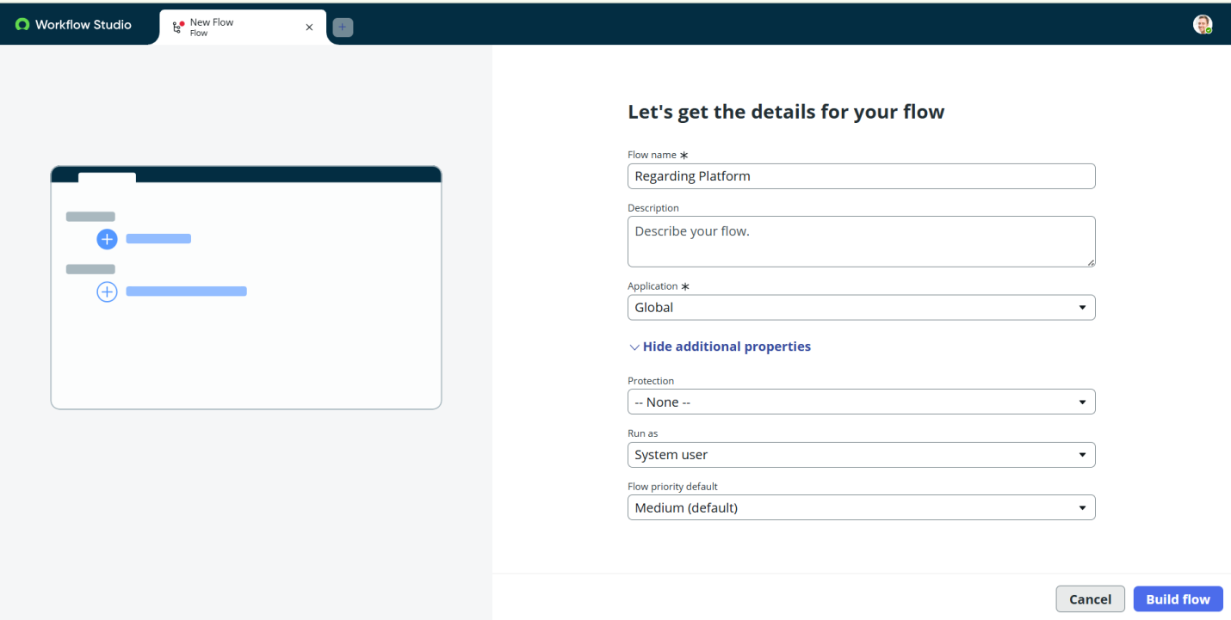

Click on Add a trigger

Select the trigger in that Search for “create or update a record” and select that.

Give the table name as “ Operations related ”.

Give the Condition as

Field : issue

Operator : is

Value : Unable to login to platform

Click on New Criteria

Field : issue

Operator : is

Value : 404 Error

Click on New Criteria

Field : issue

Operator : is

Value : Regrading User expired

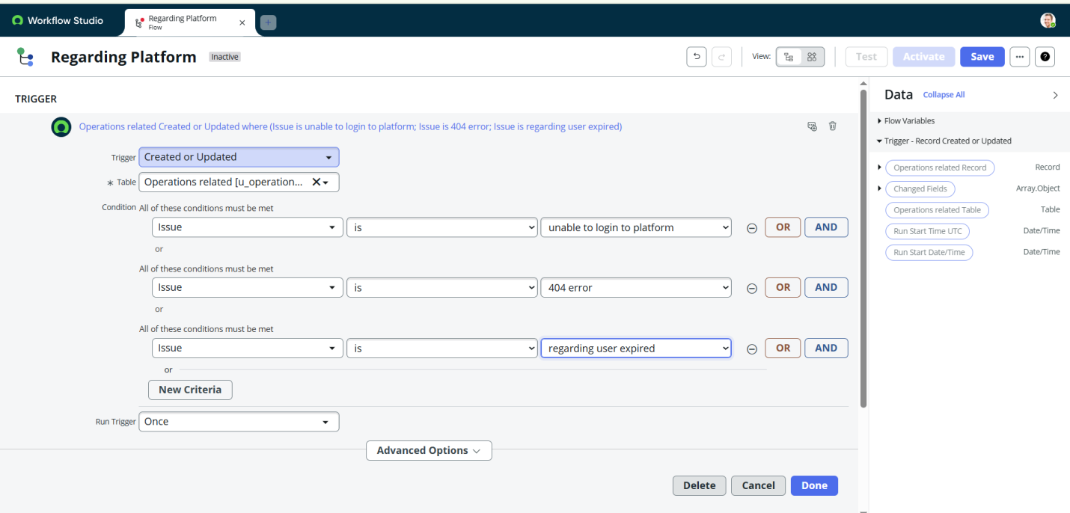

After that click on Done.

Now under Actions.

Click on Add an action.

Select action in that search for “ Update Record ”.

In Record field drag the fields from the data navigation from left side

Table will be auto assigned after that

Give the field as “ Assigned to group ”.

Give value as “ Platform ”.

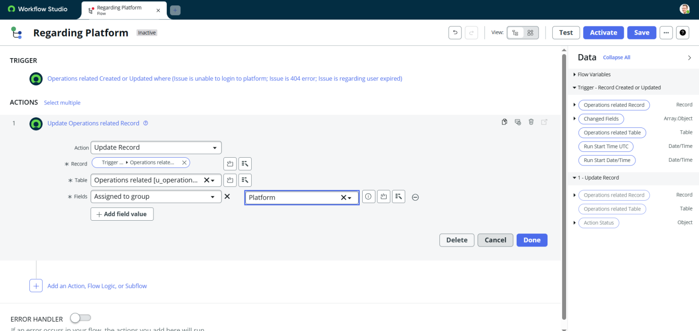

Click on Done.

Click on Save to save the Flow.

Click on Activate.

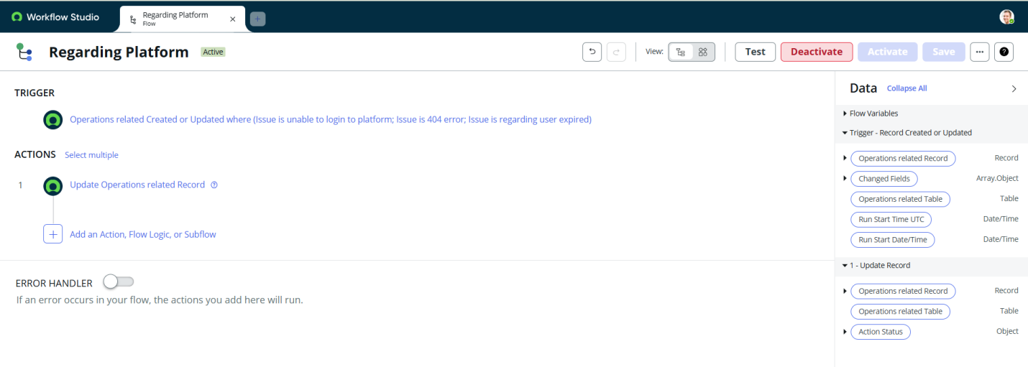

**Conclusion**

The implementation of the automated ticket routing system at ABC Corporation has been a significant success. By leveraging the capabilities of ServiceNow, we have streamlined the process of assigning support tickets to the appropriate teams, addressing the challenges of manual routing, and ensuring timely resolution of issues.